



**Module:** Web Design

**Submitted To:** Sam Cogan

**Project:** Web Design Project

**Name:** Joshua Cassidy

**Student Number**: X15378586

**Link to Github Repository:** https://github.com/joshuacassidy/Web-Design-Project-2016

**Link to Website:** http://individualsites.gear.host/

**What is the purpose does your Website have?**

To have a website built that offers the service of building websites, website maintenance, content management services and web support for issues with websites that they have built.

**What makes you unique from other Web Design companies?**

IndividualSites offer low-cost websites made by students that have access to the most recent technologies.

**What the style of the website that would suit your needs the most?**

The client would like a professional customized responsive website that has been developed using bootstrap. The website should also be supported on Mobile, Tablets and Desktop browsers.

**What is the content you would like on your website?**

The site should consist of four pages these being a home page, a services page, about page and a contact page. The services page should clearly outline the services that individual sites has to offer. The about page should contain information about the company such as who they are and how they develop their websites, the contact page should contact information about the company, a contact form and a map from Google maps where they are based. The home page should have a slider and be simple. The website should have a clear clean navigation bar that is easy to use.

**Is there any preference of colors that IndividualSites would like displayed?**

Yes. IndividualSites would prefer white, gray and black to be the main colors displayed.

**Where do you want your website to be hosted?**

Ideally, IndividualSites should be hosted on GearHost.

**When do you want IndividualSites Deployed by?**

The eighteenth of December.

**What content Should be on the Home Page?**

A title that welcomes the user and advertises our services and a link that leads the user to our contact page.

**What content should be on the Services Page?**

There should be a slider with web design related images and the services that we provide should also be outlined on this page.

**What content should be on the Contact Page?**

There should be a contact form, a map that shows where we are and our contact information such as our Phone number, email and address.

**What content should be on the About Page?**

The about page should contain information about who we are and our development process.

**Can you supply the images that you would like displayed on this website?**

The client has already picked the images they would like displayed on the website.

**Have you decided on a domain name for you Website yet?**

Yes, the preferred domain name for our website is individualsites.gear.host.

**What do you plan to do in regards to maintaining your website?**

We plan to maintain it ourselves.

**Wireframes**

**Figure 1.1: Desktop Home Page**

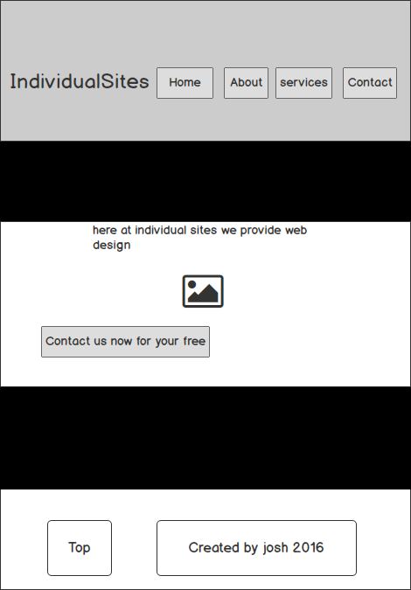

**Figure 1.2: Mobile Home Page**

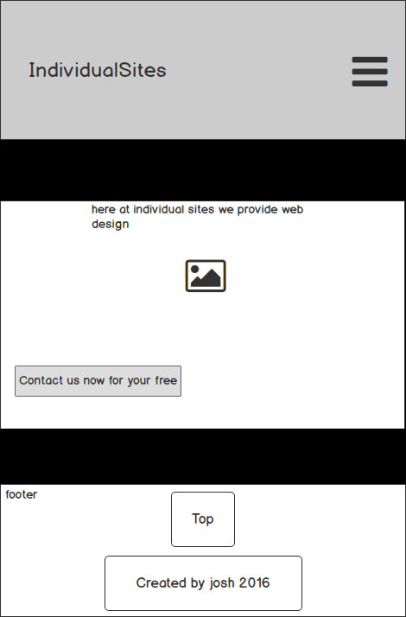

**Figure 1.3: Desktop About Page**

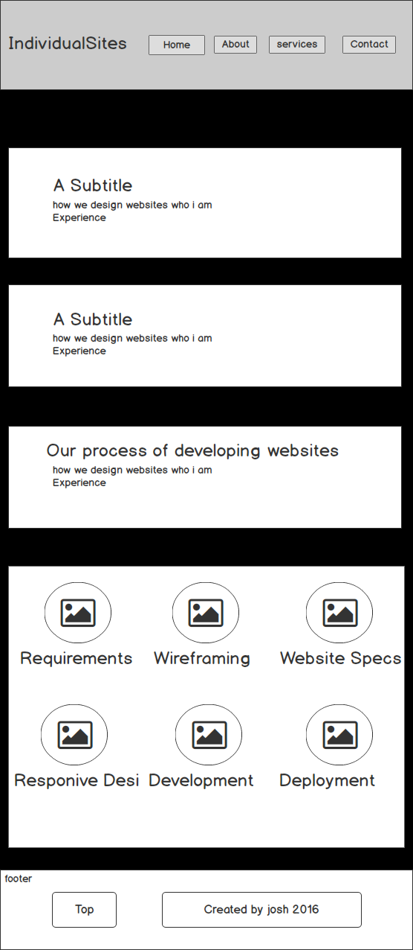

**Figure 1.4: Mobile About Page**

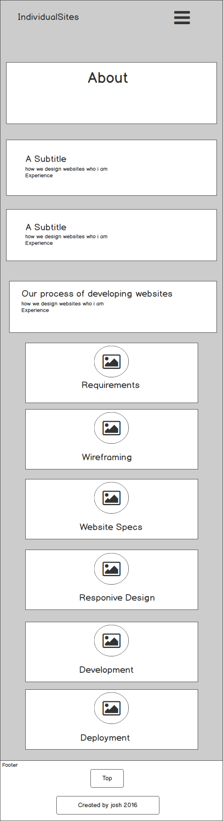

**Figure 1.5: Desktop Services Page**

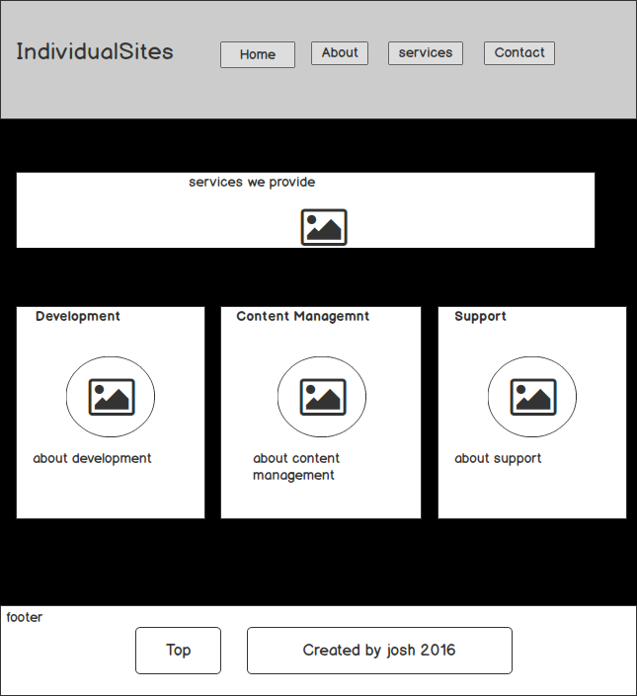

**Figure 1.6: Mobile Services Page**

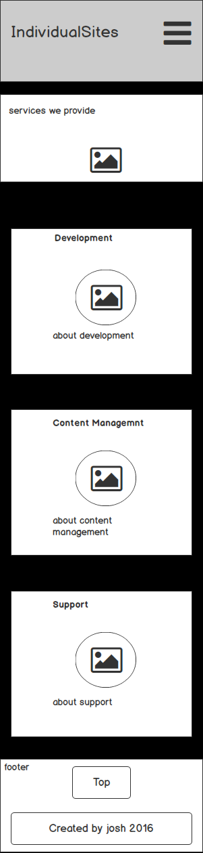

**Figure 1.7: Desktop Contact Page**

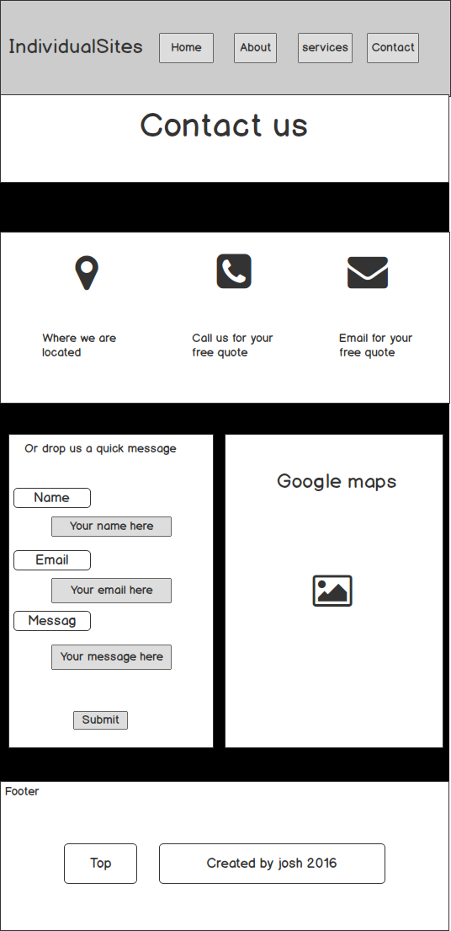

**Figure 1.8: Mobile Contact Page**

